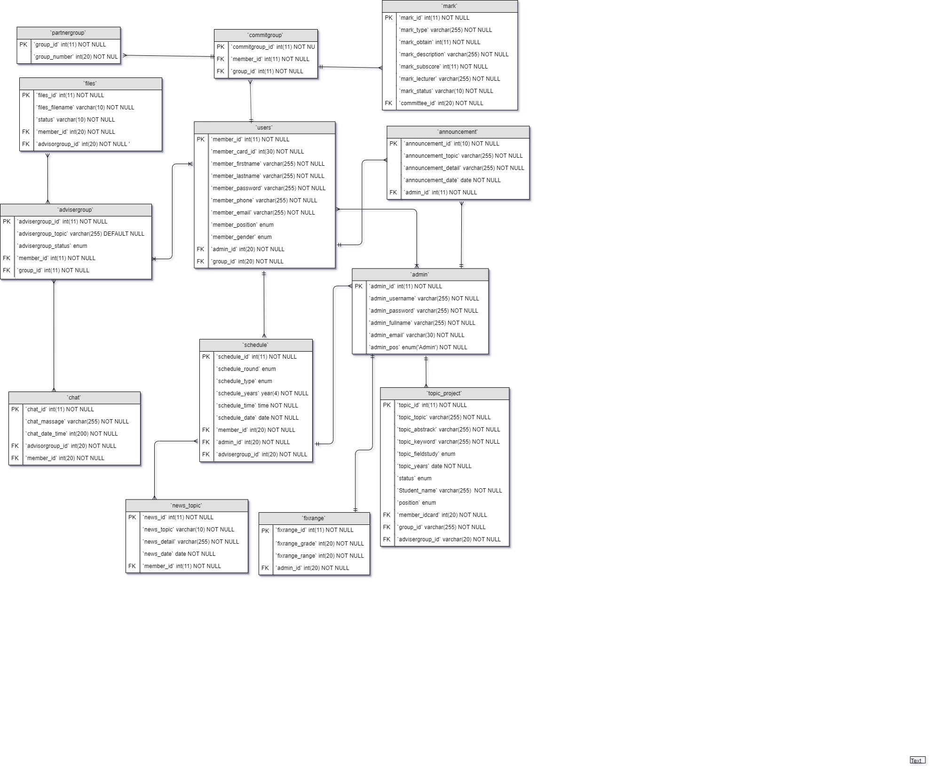

|  |  |  |  |  |  |  |
| --- | --- | --- | --- | --- | --- | --- |
| **Table Name: Admin** | | | | | | |
| **Field** | **Type** | **Length** | **Description** | **Key** | **Reference** | **Null** |
| admin_id | INT | 11 | Auto increment | PK | - | No |
| admin_username | Varchar | 255 | username of admin | - | - | No |
| admin _password | Varchar | 255 | password of admin | - | - | No |
| admin _firstname | Varchar | 255 | firstname of admin | - | - | No |
| admin _lastname | Varchar | 255 | lastname of admin | - | - | No |
| admin _email | Varchar | 255 | Admin’s email | - | - | No |
| admin _phone | Varchar | 255 | Admin’s phone | - | - | No |
| admin _position | Varchar | 255 | Admin’s position | - | - | No |

|  |  |  |  |  |  |  |
| --- | --- | --- | --- | --- | --- | --- |
| **Table Name: Users** | | | | | | |
| **Field** | **Type** | **Length** | **Description** | **Key** | **Reference** | **Null** |
| member_id | INT | 11 | Auto increment | PK | - | No |
| member_username | Varchar | 255 | username of member | - | - |  |
| member _firstname | Varchar | 255 | firstname of member | - | - | No |
| member _lastname | Varchar | 255 | lastname of member | - | - | No |
| member _password | Varchar | 255 | password of member | - | - | No |
| member_lect_std | Varchar | 255 | ID of member | - | - | No |
| member_phone | Varchar | 255 | Member’s phone | - | - | No |
| Member_email | Varchar | 255 | Member’s email | - | - | No |
| member_position | Enum | - | The position of member  1. officer  2. Lecturer  3. student | - | - | No |
| member_gender | Varchar | 255 | Memer’s gender | - | - | No |
| admin_id | INT | 11 | The foreign key to table admin | FK | table admin  admin_id | No |
| group_id | INT | 11 | The foreign key to table [partnergroup](http://localhost/phpmyadmin/sql.php?db=finalproject&table=partnergroup) | FK | table [partnergroup](http://localhost/phpmyadmin/sql.php?db=finalproject&table=partnergroup)  group_id | No |

|  |  |  |  |  |  |  |
| --- | --- | --- | --- | --- | --- | --- |
| **Table Name: Partner Group** | | | | | | |
| **Field** | **Type** | **Length** | **Description** | **Key** | **Reference** | **Null** |
| group_id | INT | 11 | Auto increment | PK | **-** | No |
| group_number | Varchar | 255 | Number of partners | - | **-** | No |

|  |  |  |  |  |  |  |  |  |  |  |  |  |  |  |
| --- | --- | --- | --- | --- | --- | --- | --- | --- | --- | --- | --- | --- | --- | --- |
| **Table Name: Advisor Group** | | | | | | | | | | | | | | |
| **Field** | **Type** | | **Length** | | **Description** | | | **Key** | | **Reference** | | **Null** | |
| advisorgroup_id | INT | | 11 | | Auto increment | | | PK | | - | | No | |
| advisorgroup_topic | Varchar | | 255 | | Group’s topic | | | - | | - | | No | |
| advisorgroup_status | Enum | | - | | 1. Approved  2. Not Approved | | | - | | - | | No | |
| group_id | INT | | 50 | | The foreign key to table partner group | | | FK | | table [partner group](http://localhost/phpmyadmin/sql.php?db=finalproject&table=partnergroup)  group_id | | No | |
| member_id | INT | | 50 | | The foreign key to table users | | | FK | | table users  member_id | | No | |
|  |  | |  | |  | | |  | |  | |  | |
| **Table Name: Announcement** | | | | | | | | | | | | |
| **Field** | | **Type** | | **Length** | | **Description** | **Key** | | **Reference** | | **Null** | |
| announcement_id | | INT | | 11 | | Auto increment | PK | | - | | No | |
| announcement_topic | | Varchar | | 255 | | Topic of annouce | - | | - | | No | |
| announcement_date | | Date | | 50 | | Date and time of annouce | - | | - | | No | |
| announcement _detail | | Varchar | | 50 | | Detail of annouce | - | | - | | No | |
| admin_id | | INT | | 50 | | The foreign key to table admin | FK | | table admin  admin_id | | No | |

|  |  |  |  |  |  |  |
| --- | --- | --- | --- | --- | --- | --- |
| **Table Name: Chat** | | | | | | |
| **Field** | **Type** | **Length** | **Description** | **Key** | **Reference** | **Null** |
| chat_id | INT | 11 | Auto increment | PK | **-** | No |
| Chat_massage | Varchar | 255 | Chat message | - | **-** | No |
| Chat_date_time | Date | - | Chat Date | - | **-** | No |
| member_id | INT | 11 | foreign key to users table | FK | users table  member_id | No |
| advisorgroup_id | INT | 11 | Foreign key to  advisorgroup table | FK | advisorgroup table  advisorgroup_id | No |

|  |  |  |  |  |  |  |
| --- | --- | --- | --- | --- | --- | --- |
| **Table Name: Committee group** | | | | | | |
| **Field** | **Type** | **Length** | **Description** | **Key** | **Reference** | **Null** |
| committee_id | INT | 11 | Auto increment | PK | **-** | No |
| member_id | INT | 11 | foreign key to users table | FK | users table  member_id | No |
| group_id | INT | 11 | foreign key to Partner Group table | FK | Partner Group table group_id | No |

|  |  |  |  |  |  |  |
| --- | --- | --- | --- | --- | --- | --- |
| **Table Name: files** | | | | | | |
| **Field** | **Type** | **Length** | **Description** | **Key** | **Reference** | **Null** |
| files_id | INT | 11 | Auto increment | PK | - | No |
| files_filename | Varchar | 255 | Name of files | - | - | No |
| status | INT | 11 | Status of files | - | - | No |
| advisorgroup_id | INT | 11 | foreign key to Advisor Group table | - | Advisor Group table advisorgroup_id | No |
| member_id | INT | 11 | foreign key to users table | FK | users table  member_id | No |

|  |  |  |  |  |  |  |
| --- | --- | --- | --- | --- | --- | --- |
| **Table Name: Fix range** | | | | | | |
| **Field** | **Type** | **Length** | **Description** | **Key** | **Reference** | **Null** |
| fixrange_id | INT | 11 | Auto increment | PK | - | No |
| fixrange_grade | Varchar | 255 | grade of Fix range | - | - | No |
| fixrange_range | INT | 11 | range of Fix range | - | - | No |
| admin_id | INT | 11 | The foreign key to table admin | FK | table admin  admin_id | No |

|  |  |  |  |  |  |  |
| --- | --- | --- | --- | --- | --- | --- |
| **Table Name: Mark** | | | | | | |
| **Field** | **Type** | **Length** | **Description** | **Key** | **Reference** | **Null** |
| mark_id | INT | 11 | Auto increment | PK | - | No |
| mark_type | Varchar | 255 | Type of mark | - | - | No |
| mark_obtain | INT | 50 | Obtain_ of mark | - | - | No |
| mark_description | Varchar | 255 | Description of mark | - | - | No |
| mark_subscore | INT | 20 | Subscore of mark | - | - | No |
| mark_lecturer | Varchar | 255 | Lecturer of mark | - | - | No |
| mark_status | Varchar | 10 | Status of mark | - | - | No |
| committee_id | INT | 20 | The foreign key to table [committeegroup](http://localhost/phpmyadmin/sql.php?db=finalproject&table=committeegroup) | FK | table [committeegroup](http://localhost/phpmyadmin/sql.php?db=finalproject&table=committeegroup)  committee_id | No |

|  |  |  |  |  |  |  |
| --- | --- | --- | --- | --- | --- | --- |
| **Table Name: Schedule** | | | | | | |
| **Field** | **Type** | **Length** | **Description** | **Key** | **Reference** | **Null** |
| schedule_id | INT | 11 | Auto increment | PK | - | No |
| schedule_round | Varchar | 255 | Round of schedule | - | - | No |
| schedule_type | Enum | - | Types of schedule | - | - | No |
| schedule_years | Varchar | 255 | Years of schedule | - | - | No |
| schedule_time | INT | 20 | Time of schedule | - | - | No |
| schedule_date | Varchar | 255 | Date of schedule | - | - | No |
| schedule_room | Varchar | 255 | Room for exam or present proposal or project | - | - |  |
| member_id | Varchar | 10 | The foreign key to table users | FK | table [users](http://localhost/phpmyadmin/sql.php?db=finalproject&table=committeegroup)  member_id | No |
| group_id | INT | 20 | The foreign key to table [partner](http://localhost/phpmyadmin/sql.php?db=finalproject&table=committeegroup)group | FK | Table [partner](http://localhost/phpmyadmin/sql.php?db=finalproject&table=committeegroup)group group  [partner](http://localhost/phpmyadmin/sql.php?db=finalproject&table=committeegroup)group _id | No |

|  |  |  |  |  |  |  |
| --- | --- | --- | --- | --- | --- | --- |
| **Table Name: Topic Project** | | | | | | |
| **Field** | **Type** | **Length** | **Description** | **Key** | **Referent** | **Null** |
| topic_id | INT | 11 | Auto increment | PK | - | No |
| topic_topic | Varchar | 255 | topic of project | - | - | No |
| topic_abstrack | Varchar | 255 | Abstrack of project | - | - | No |
| topic_keyword | Varchar | 255 | Keyword of project | - | - | No |
| topic_fieldstudy | Enum | - | Field study of project | - | - | No |
| topic_years | Varchar | 255 | Years of project | - | - | No |
| status | Varchar | 50 | Status of project | - | - | No |
| Student_name | Varchar | 255 | Name student of project | - | - | No |
| position | Enum | - | 1. Admin  2. Student | - | - | No |
| adviser | Varchar | 255 | Advisor project of student | - | - | No |
| member_id_card | INT | 20 | ID student of project | - | - | No |
| Advisorgroup_id | INT | 20 | The foreign key to table advisorgroup | FK | table [advisorgroup](http://localhost/phpmyadmin/sql.php?db=finalproject&table=committeegroup)  advisorgroupr_id | No |

|  |  |  |  |  |  |  |
| --- | --- | --- | --- | --- | --- | --- |
| **Table Name: News Topic** | | | | | | |
| **Field** | **Type** | **Length** | **Description** | **Key** | **Reference** | **Null** |
| news_id | INT | 11 | Auto increment | PK | - | No |
| news_topic | Varchar | 255 | Topic of News | - | - | No |
| news_detail | Enum | - | Detail of News | - | - | No |
| news_date | Varchar | 255 | Date of News | - | - | No |
| member_id | Varchar | 10 | The foreign key to table users | FK | table [users](http://localhost/phpmyadmin/sql.php?db=finalproject&table=committeegroup)  member_id | No |